**Experiment No. 02**

|  |  |
| --- | --- |
| Name: Kamran Khan | Roll No: 11 |
| Subject: High Performance Parallel Computing | Class/Batch: CSE-AIML / B1 |
| Date of Performance: __ / __ / 2024 | Date of Submission: __ / __ / 2024 |

**AIM**

**Writing a program in java to implement Multithreading in java, via Extending the `Thread` class method.**

**Theory / Procedure / Algorithm**

**Sample Code using** *`Thread class`*

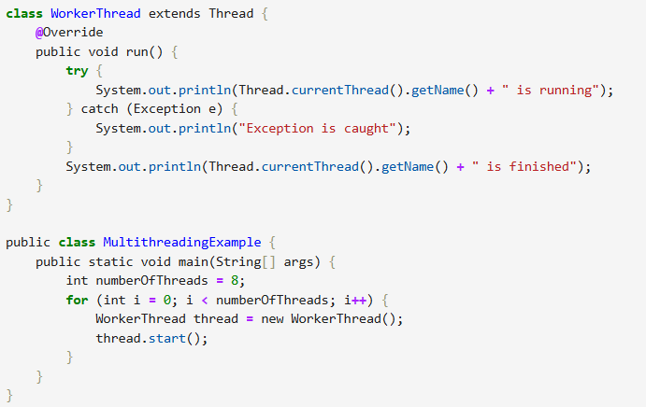

**Explanation:**

**Reference:**

* <https://www.geeksforgeeks.org/java-multithreading-tutorial/>
* <https://www.geeksforgeeks.org/multithreading-in-java/>

**CONCLUSION**

**ASSESSMENT**

|  |  |  |  |  |
| --- | --- | --- | --- | --- |
| **Timely Submission (07)** | **Presentation (06)** | **Understanding (12)** | **Total (25)** | **Sign** |
|  |  |  |  |  |